**12 PSYCHOLOGY WORLD EVENT AND PTSD PROJECT 2016**

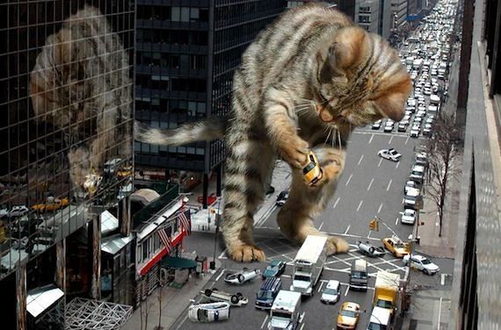

Name:__________________________ Form:_________________

Teacher: Miss Cerny Due date: Tuesday 13th September

**Broad context:** Healthy lifestyle, diversity and community.

**Task type:** Project.

**Key concepts:** Mental illness.

Development

**Task:**

This task requires you to choose a world event and analyse it in terms of sources of stress, community resilience, negative mental health impacts and positive mental health impacts displayed by the population. The task then asks that you focus on post-traumatic stress disorder and investigate its symptoms and treatments.

**Select a world event from the list below or choose your own:**

September 11 attacks in 2001

Black Sunday Bushfires in Victoria 2009

Christchurch earthquake in 2011

Cyclone Tracey

Hurricane Katrina

**Suggested resources available in the classroom:**

Book: Dr. Michelle Lind. Understanding Post-Traumatic Stress Disorder: The Long Arm of PTSD Can Span Generations.

Book: Post-Traumatic Stress Disorder: National Institute of Mental Health

Book: Page 265- 271 Psychology Self and Others text book

Book: Page 583-584 Psychology First European Edition

**Requirements for assessment**

➊ Project in one of the following forms: video, PowerPoint Presentation, Prezi, booklet, brochure, poster, comic strip.

➋ This assessment booklet.

**Plagiarism:**

You must write in your own words not copy sentences word for word from another student or another source.

Plagiarising = instant zero on assignment and you will have to re-do it.

**Assessment policy:**

Give me a sick note/legitimate reason from parent BEFORE due date = new negotiated due date.

One day late = -20% taken off mark

Two days late = -40% taken off mark

Three days late = mark of zero given, students are required to attend a detention and are still required to submit the assignment.

**If you are not at school the day this assignment is due, please email it to me by 4pm.**

**s.cerny@aranmore.wa.edu.au**

**In your project include the following:**

World events can affect individual wellbeing and are often sources of stress. Directly relating to your chosen event, **analyse** the three event characteristics about events that determine whether or not we experience them as stressful.

**Explain** what the term ‘community resilience’ refers to and **describe** how community resilience was displayed after your selected world event.

**Describe** negative mental health impacts experienced by the population affected by the world event.

**Describe** positive mental health impacts (post traumatic growth) experienced by the population affected by the world event.

According to the DSM-5, **state** what an official diagnosis of PTSD requires.

**Explain** what the ‘DSM-5’ is.

**Describe** four symptoms of PTSD.

**Explain** two ways in which sufferers of PTSD are treated.

**Briefly describe** one theory that tries to explain why some people suffer PTSD while others who have experienced the same event do not.

**Marking Key**

|  |  |  |  |
| --- | --- | --- | --- |
| **Content** | **Description** | **Possible**  **mark** | **Your**  **mark** |
| World event | Briefly stated when and where event occurred.  Analysed three event characteristics that determined whether event was stressful.  Explained ‘community resilience’ and described how it was displayed after the event.  Described negative mental health impacts experienced by population affected by event.  Described positive mental health impacts experienced by population affected by event. | 1  6  3  2  2 |  |
| Post-traumatic  stress disorder | Included official diagnosis requirements of PTSD according to the DSM-5.  Explained what the DSM-5 is.  Described four symptoms of PTSD.  Explained two ways in which PTSD sufferers are treated.  Described one theory that tries to explain why some people suffer PTSD and others who have experienced the same event do not. | 2  2  8  4  2 |  |
| Referencing | Referenced correctly using APA style.  Minimum of two references. | 1  1 |  |
| Presentation | Correct spelling and grammar.  Subheadings were used.  Project was neat and layout made it easy to follow. | 1  1  1 |  |
| **Total mark** | | 37 |  |

Mark as percentage: %

Teacher’s comment is on Seqta

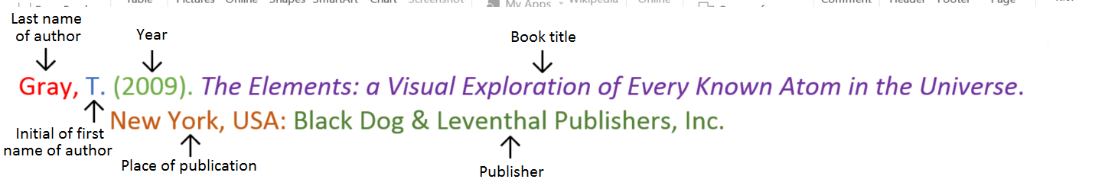**Book**

**Book with two authors**

Shermer, M., & Benjamin, A. (2006). *Secrets of Mental Math: The Mathemagician’s Guide to Lightning Calculation*

*and Amazing Mental Math Tricks*. New York, USA: Three Rivers Press.

**Book with three or more authors**

Bulliet, R. W., Alley, R. B., Broecker, W. S., & Denton, G. H. (2011). *The fate of Greenland: Lessons from abrupt climate*

*change*. Cambridge, MA: MIT Press.

**Book with editor**

Kasdorf, W. E. (Ed). (2003). *The Columbia guide to digital publishing*. New York, USA: Columbia University Press.

**Book with different editions**

Nagle, G., & Cooke, B. (2012). *Geography Study Guide: Oxford Ib Diploma Programme* (2nd ed.). Oxford,

UK: Oxford University Press.

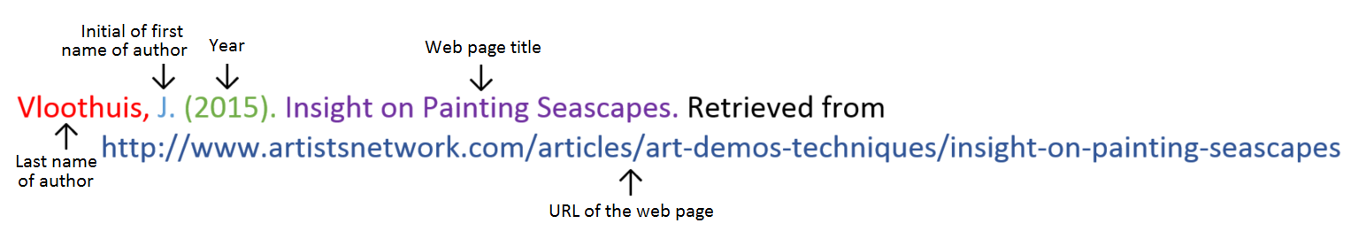**Website**

**Website with no author** (put title of page at the front)

Aranmore Catholic College. (2014). Retrieved from http://www.aranmore.wa.edu.au/

**Website with no date**

The Zadkine Museum. (n.d). Retrieved from http://www.france.fr/en/museums/zadkine-museum.html

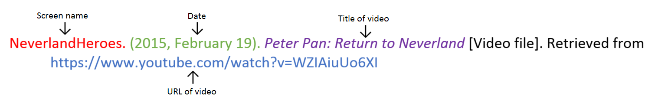**Video file**

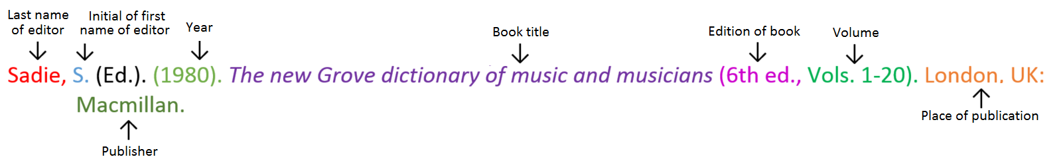**Encyclopaedia or dictionary**

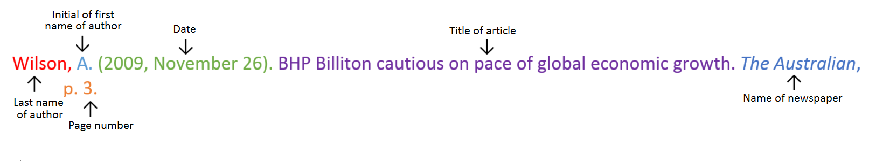**Newspaper article: print**

**Newspaper article: online**

Seelye, K. Q. (2012, December 3). Spate of harsh weather in New England shifts sentiment on trees. *The*

*New York Times.* Retrieved from http://www.nytimes.com

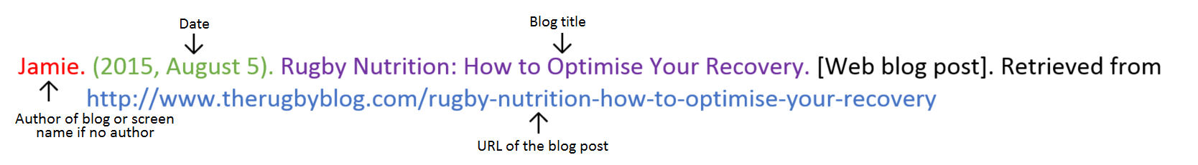**Blog**

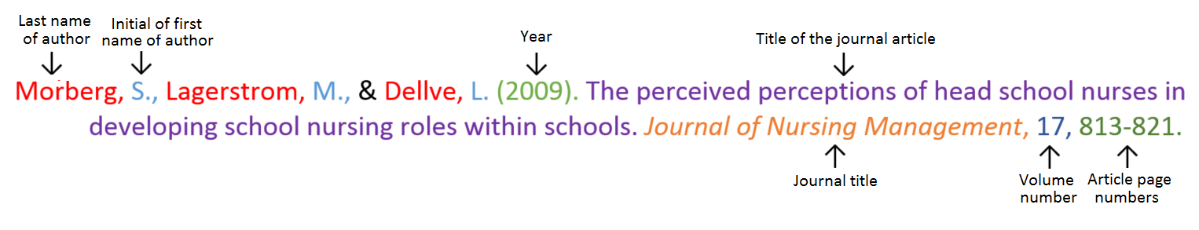**Journal article: print**

**Journal article: electronic** (use the journal homepage as the website)

Hallam, R. S., & Bender, M. P. (2012). The journal of a mental hospital user in the 1960s. *The Psychologist*, 25, 394-

395. Retrieved from www.thepsychologist.org.uk

**Reference list**

_________________________________________________________________________________________________

_________________________________________________________________________________________________

_________________________________________________________________________________________________

_________________________________________________________________________________________________

_________________________________________________________________________________________________

_________________________________________________________________________________________________

_________________________________________________________________________________________________

_________________________________________________________________________________________________

_________________________________________________________________________________________________

_________________________________________________________________________________________________

_________________________________________________________________________________________________

_________________________________________________________________________________________________

_________________________________________________________________________________________________

_________________________________________________________________________________________________

_________________________________________________________________________________________________